## Todo: to record all of the following “transcripts”

Electronic Commerce: what is e-commerce



# Part 1)

## 1ST row) Identity theft 个人信息被盗

## Lexical resource

* 客户端字体 font face   
  e.g .The @font-face rule is used to exhaustively describe a font face (客户端字体)for use in a document.
* E-commerce: buying or selling goods over the internet by the online retailer, not in the **brick-and-mortar store/location实体店**e.g **With the advent of** online businesses, more and more **brick-and-mortar stores实体店**, esp. the **mom-and-pop stores** 小型的商店, have **gone bust/gone bankrupt** or are endangering.
* **mom-and-pop  ['mɔmənd'pɔp]** adj. small and privately-owned business 夫妻经营的；家庭经营的; 小型的(商店,生意) **[ mom-and-pop business; mom-and-pop hotel; mom-and-pop store]**
* **不劳而获／天上掉馅饼 [ get something for nothing ]** e.g. Don't be so **childish and naive孩子气** if you think you can **get something for nothing**.  如果你认为你能够”不劳而获／天上掉馅饼”。　   
  e.g. **I don’t believe there is windfall in life = I don't believe that you can [get something for nothing] in life 我不相信 "不劳而获" = 有天上掉馅饼**  
  V.S.
* **windfall /ˈwɪndˌfɔːl/** A windfall is a su[**m o]**f money or fortune that you receive unexpectedly, esp. by luck, for example, if you win a lottery**['lɒt(ə)rɪ].** (N) 意外之财 ，天上掉的馅饼(不劳而获得到的东西**) [ windfall or windfall profits 意外之财 ]**e.g....the man who received a $250,000 **windfall (profits)**  because of a minor banking **oversight**/negligence疏忽因银行一个很小的疏忽,得到25万美元　**意外之财**   
  e.g. **I believe there is no windfall in life = I don't believe that you can [get something for nothing] in life 我不相信 "不劳而获" = 有天上掉馅饼**
* 交易流水账单**account statement**: a statement of recent transactions and the **resulting** balance. E.g. I’m used to checking my account **statement** monthly. If there is anything weird, I would report the risk asap.
* **进行诈骗 commit fraud/scam/shenanigan [ business fraud/scam/shenanigan ]**E.g. A) I doubt that any **scammers诈骗者** are interested in my bank account because I don’t have money in my account. B)But what about **identity theft**? They could use your personal details to **commit fraud/scam/shenanigan　进行诈骗.**
* Business fraud/scam/shenanigan; fraudulent, fraudulently

e.g A scam artist will try to con you into giving him or her your personal details. Identity theft is when your personal details have been stolen or released and used by thieves to buy things , esp. to **commit fraud/scam/shenanigan**进行诈骗 Be wary of phishing emails. 个人信息被盗

* scam, scammer/ˈskæmə/, scam artist: 专职诈骗者, 诈骗专家

e.g. There are some people who are taking the fight to the **scammers**. These people are known as internet **vigilantes治安维持会成员 [,vɪdʒɪ'læntɪ]**, or digilantes.

* con /kɒn/  哄骗  
  1.V-T If someone **cons you** or **cons you into doing sth**, they persuade or **entice**诱使 you to do something or believe something by telling you things that are not true. 哄骗   
  e.g. A scam artist will try to **con you into giving** him or her your personal details. **Identity theft** is when your personal details have been stolen or released and used by thieves to buy things, esp. to **commit fraud/scam/shenanigan**进行诈骗Be wary of phishing emails. 个人信息被盗

e.g. He claimed that the businessman **had conned him of** $10,000. 那个商人 **哄骗** 了他1万美元。

N) A con is a trick in which someone deceives you by telling you something that is not true. 骗局. E.g. Snacks that offer miraculous weight loss are a **con**. 那些可以神速减肥的快餐食品是个**骗局**。

N) an argument or vote against a proposal, motion, etc 反对的理由; 反对的投票

N) **[ pros and cons ]**

* A phishing scam

What is “phishing”: When **scam artists** send email with links that look authentic, but actually it’s fake and malicious, used to entice your greed to buy something or set up a sort of an account for example, **whereby/by which借此**, your confidential personal information is normally stolen, that is you encounter the **“identity theft”.**

* phishing email   
  e.g. A **scam artist** will try to **哄骗欺诈con you into giving** him or her your personal details. **Identity theft** is when your personal details have been stolen or released and used by thieves to **commit fraud/scam/shenanigan**进行诈骗. **Be wary of** phishing emails. 个人信息被盗
* entice /ɪnˈtaɪs/, enticing 引诱的 ( sth looks enticing)

1.V-T To entice someone to go somewhere or to do something means to try to persuade them to go to that place or to do that thing. 引诱,怂恿sb做xxxx e.g. They'll **entice thousands of doctors to** move from the cities to the rural areas by paying them better salaries. 他们将通过支付更高的薪水怂恿成千上万的医生从城市迁往农村。 E.g. Retailers have tried almost everything, from cheap credit to free flights, to **entice shoppers** through their doors. 从低价信贷到免费航班，**零售商们几乎用尽一切办法引诱,怂恿**购物者惠顾

* 诱人的enticing **[ enticing benefits ]**   
  1.ADJ Something that is enticing is extremely attractive and makes you want to get it or to become involved with it. 诱人的 e.g. A prospective premium of about 30 percent on their initial investment is **enticing**. 初始投资30％左右的预期收益是诱人的
* 风趣; 诙谐，机智wit /wɪt/(N):  Wit is the ability to use words or ideas in an amusing, clever, and imaginative way. e.g. Tracy was known for his mocking wit. 博尔丁以其嘲讽式的风趣而出名。

2.N-SING If you say that **sb. has the wit to do something**, you mean that they have the intelligence and understanding to make the right decision or take the right action in a particular situation. 才智/机智 e.g. ZhuGeLiang, one the most famous and prestigious military strategist, always **has the wit to deal** with any military risks. E.g. The information is there and waiting to be accessed by **anyone with wits** to use it. 信息是现成的，等着有(**机智)头脑**的人去获取和利用。

3.N-PLURAL You can refer to your ability to think quickly and effectively in a difficult situation as your wits. **机智/头脑** e.g. She has used her **wits** to progress to the position she holds today. 她用她的**机智/头脑** 攀升到今天的这个位置。

4. You can use wits in expressions such as **frighten someone out of their wits** and **scare the wits out of someone** to emphasize that a person or thing worries or frightens someone very much. **把我们的头脑给吓出来了=把我们吓坏了**

e.g. You scared us **out of our wits**. We heard you had an accident. 你把我们吓坏了。

* witty /ˈwɪtɪ/  sb. or sth that is witty is **amusing** and funny in a **clever** way. 诙谐的   
  e.g. His plays were very good, very witty. 他的那些剧作非常好，非常诙谐
* vigilant, vigilance, **vigilante**

 Someone who is vigilant gives careful attention to a particular problem or situation and concentrates on noticing any danger or trouble that there might be, **vigilant = eye-opened 警惕的 V.S. prudent 谨慎的** e.g. He warned the public to be vigilant and report anything suspicious. 他告诫公众要保持警惕 e.g. Constant vigilance is needed to combat this evil. 同这种邪恶作斗争需要时刻保持警惕

* **vigilante /ˌvɪdʒɪˈlæntɪ/  义务警员；治安维持会成员**

1.N-COUNT Vigilantes are people who organize themselves into an unofficial group to protect their community and to catch and punish criminals. E.g. The vigilantes /ˌvɪdʒɪˈlæntɪ/  dragged the men out. 联防队员们把那些男子拖了出来

e.g. There are some people who are taking the fight to the **scammers**. These people are known as **internet vigilantes治安维持会成员 [,vɪdʒɪ'læntɪ]**, or digilantes.

* 值夜班; (祈祷或政治抗议的) 守夜vigil /ˈvɪdʒɪl/

A vigil is a period of time when people remain quietly in a place, especially at night, for example, because they are praying or are making a political protest. E.g. Protesters are holding a twenty-four hour vigil **sit-in** outside the socialist party headquarters. 抗议者正在社会党总部外面举行24小时的静坐示威。

2.  If someone **keeps a vigil or keeps vigil somewhere**, they remain there quietly for a period of time, especially at night, for example,because they are praying or are making a political protest. 守夜

* wary /ˈwɛərɪ/ a), warily, wariness = **prudent 谨慎的**

1.ADJ If you are wary of something or someone, you are cautious because you do not know much about them and you believe they may be dangerous or cause problems. 小心的; 提防的 e.g. People did not teach their children to be wary of strangers. 人们以前没教过自己的孩子们要提防陌生人。

2.ADV 小心地; 谨慎地 warily e.g. She studied me warily, as if I might turn violent. 她警惕地盯着我，好像我会变得很粗暴似的

* intro => introspect, introspection /ˌɪntrəˈspɛkʃən/ v.s. intercept the missile

Introspection is the examining of your own thoughts, ideas, and feelings. 自省; 反省 e.g. He had always had his moments of quiet introspection. 他总有安静自省的时候

## Mp3Done) video: Identity theft个人信息被盗





 



* **account statement: 账号的流水清单 * con sb * be wary of = prudent, vigilant**





























Guess what? These materials never arrive. * entice sb. to do => sth looks enticing .













* wit:  You can refer to your ability to think quickly and effectively in a difficult situation as your wits. 机智

## 2nd row)

|  |
| --- |
| Beware of Identity Theft! **Identity theft** (个人信息被盗)is when your personal details, esp. bank card information, have been stolen or released and used by thieves to buy things, esp. to **commit fraud/scam/shenanigan**进行诈骗**Be wary of** phishing emails |
| Sarah Walker knows all too well how easy it is to be a victim of fraud. In 2004, while she was paying for dinner with her credit card, someone in the restaurant stole the number. “When I got my credit card statement, I discovered someone was using my card to buy electronics that I could never afford!” she explains.  Since then, Sarah has been especially concerned about identity theft. So she is extremely careful with personal information, including her name, address and bank account number. “Yes, I am very cautious!” she says, “I don’t even throw away junk mail with my personal information on it. I burn or shred that kind of thing!”  The internet is another place where she is cautious. “The internet is an exciting technology…I like online shopping, but there’s so much buying and selling online, it’s easy to accidentally give untrustworthy people your personal information. So I think the internet can also be a confusing technology.”  Sarah is wise to consider the dangers of the internet. Whereas, in the past, scam artists found their victims while they were looking for personal information in people’s garbage and recycling, today they are finding their victims online, too.  Would you like to learn how to protect yourself online? |

## Dialogue

Scamming has become really prevalenｔ盛行 in the days of e-commerce. While reading the news , I heard about a ring of **scam artists** called 'The Black Plague.' They had been **conning** senior citizens for 10 years. I immediately looked at my account transactions online, being **paranoid** . Turns out I had some **fraudulent** transactions. The bank is working on investigating the cause of the **fraud**, but I'll bet it's 'The Black Plague' stealing my money .

paranoid /ˈpærəˌnɔɪd/

1.ADJ If you say that someone is paranoid, you mean that they are extremely suspicious and afraid of other people. 多疑的; 恐惧的 e..gI'm not going to get paranoid about it. 我不会对此过分猜疑的。

...a paranoid politician who saw enemies all around him. …一个把自己周围的人都视为敌人的多疑的政治家。

2.ADJ Someone who is paranoid suffers from the mental illness of paranoia. 患偏执狂的; 患妄想狂的

例：...paranoid delusions. …偏执狂的错觉。

3.N-COUNT A paranoid is someone who is paranoid. 偏执狂; 妄想狂 ...these sad, deluded paranoids. …这些可悲的、被蒙蔽的妄想狂们。

## 3rd row) collocation /ˌk**ɒlə**ˈkeɪʃən/  词语搭配

collocation /ˌkɒləˈkeɪʃən/  In linguistics, collocation is the way that some words occur regularly whenever another word is used. 词语搭配 e.g ...the basic notion of collocation....词语搭配的基本概念。

## Mp3Done) video

## Nice sentences

You should always keep your credit card information **confidential** and secure.

We need to be careful of those online seeking to **commit fraud** .

If you deal with a lot of people online, you need to try to avoid **identity theft**. **Identity theft** is when your personal details, esp. bank card information, have been stolen or released and used by thieves to buy things, esp. to **commit fraud/scam/shenanigan**进行诈骗 **Be wary of** phishing emails.

After you order something over the telephone or online, you should confirm the payment and shipping information.

You should be sure to check **account statements** every month.

My mother always said that you don’t get something for nothing . If something seems too good to be true, it probably is.

## 4th row): video: Talking about **identity theft** 个人信息被盗

**Identity theft:**  is when your personal details, esp. bank card information, have been stolen or released and used by thieves to buy things, esp. to **commit fraud/scam/shenanigan**进行诈骗 **Be wary of** phishing emails

A) I just love Taobao.com online shopping so much. You can buy anything there. I mean buy my groceries online there['ɡrosəri].

B) I've never heard of that site. How do you know about it?

A) Oh, well I got an email from Taobao that offering me 10% discount for the 1st purchase. So I just clicked the given link and went straight to the site.

B) You sure it's not a **phishing scam**? Following unfamiliar links is a bad idea.

A) I think it’s fine. Look, it requires you to create the password. Mine is my name followed by the **years of born,** “Bob56”.

B) That password is really weak. Use strong passwords when you shop online.

A) I know, but I’ll forget them. “bob56” is easy to remember. Plus, I doubt that any **scammers诈骗者** are interested in my bank account because I don’t have money in my account. **//scam artist诈骗老手**

B) But what about **identity theft**? They could use your personal details to **commit fraud/scam/shenanigan　进行诈骗.**

A) O yeah, it could, but risk is pretty low, don’t you think? Very few people end up with **identity theft.** Look, I’ve just downloaded a movie for free after signing up.

B) I'm **skeptical**. You don’t  **get something for nothing 不劳而获/天上掉馅饼.**

A) Oh well, I do check my **account statement** 交易流水very month. So even when something weird does happen, I can report it to the bank. Seriously, I’ve been shopping online for years and nothing bad happen.

B) OK; it's your choice. But I'd be a little more **wary**. //be wary of sth, cautious, prudent

//

* **V) 不劳而获／天上掉馅饼 [ get something for nothing ]** e.g. Don't be so **childish and naive孩子气** if you think you can **get something for nothing**.  别这么孩子气，如果你认为你能够”不劳而获／天上掉馅饼”。　   
  e.g. **I believe there is no windfall in life = I don't believe that you can [get something for nothing] in life 我不相信 "不劳而获" = 有天上掉馅饼**  
  V.S.
* **N) windfall /ˈwɪndˌfɔːl/** A windfall is a su[**m o]**f money or fortune that you receive unexpectedly, esp. by luck, for example, if you win a lottery**['lɒt(ə)rɪ].** (N) 意外之财 ，天上掉的馅饼(不劳而获得到的东西**) [ windfall or windfall profits 意外之财 ]**e.g....the man who received a $250,000 **windfall (profits)**  because of a minor banking **oversight**/negligence疏忽因银行一个很小的疏忽,得到25万美元　**意外之财**   
  e.g. **I believe there is no windfall in life = I don't believe that you can [get something for nothing] in life 我不相信 "不劳而获" = 有天上掉馅饼**

# Part 2) Choose an e-commerce site (e.g. Amazon, Taobao,)

## 1st row

## Stop: Lexical resource

* E-commerce: buying or selling goods over the internet, not in the **brick-and-mortar store/location**.

e.g **With the advent of** online businesses, more and more **brick-and-mortar stores实体店**, esp. the **mom-and-pop stores** 小型的商店, have **gone bust/gone bankrupt** or are endangering.

* **mom-and-pop  ['mɔmənd'pɔp]** adj. small and privately-owned business 夫妻经营的；家庭经营的; 小型的(商店,生意) **[ mom-and-pop business; mom-and-pop hotel; mom-and-pop store]**

reputable /ˈrɛpjʊtəbəl/  TEM8

1.ADJ A reputable company or person is reliable and can be trusted. 声誉好的 [ a reputable company V.S. disreputable company/notorioius ]

例：

You are well advised to buy your car through a reputable dealer.

你通过一个声誉好的经销商来买车是明智的

6-hr layover in LA V.S. layout V.S. outlay (necessary expenses) V.S. overhead/expense

outlay /ˈaʊtleɪ/  TEM8

1.N-VAR Outlay is the amount of money that you have to spend in order to buy something or start a project. (必要的) 费用

例：

Apart from the capital outlay of buying the machine, dishwashers can actually save you money.

抛开购买的费用不讲，洗碗机实际上能给你省钱

intuition /ˌɪntjʊˈɪʃən/  CET6 TEM8

1.N-VAR Your intuition or your intuitions are unexplained feelings that something is true even when you have no evidence or proof of it. 直觉

例：

Her intuition was telling her that something was wrong.

她的直觉在告诉她事情有些不对头

intuitive /ɪnˈtjuːɪtɪv/  TEM8

1.ADJ If you have an intuitive idea or feeling about something, you feel that it is true although you have no evidence or proof of it. 直觉的

例：

A positive pregnancy test soon confirmed her intuitive feelings.

阳性的孕检结果很快证实了她的直觉。

2.ADV 凭直觉地 intuitively

例：

He seemed to know intuitively that I must be missing my mother.

他似乎凭直觉知道我一定是在思念我的母亲

Harness

harness /ˈhɑːnɪs/  CET4 TEM8 (harnessing,harnessed,harnesses)

1.V-T If you harness something such as an emotion or natural source of energy, you bring it under your control and use it. 利用

例：

Turkey plans to harness the waters of the Tigris and Euphrates rivers for big hydro-electric power projects.

土耳其计划利用底格里斯河与幼发拉底河的水来建造大型水力发电工程。

2.N-COUNT A harness is a set of straps which fit under a person's arms and fasten around their body in order to keep a piece of equipment in place or to prevent the person moving from a place. 背带; 安全带

3.N-COUNT A harness is a set of leather straps and metal links fastened around a horse's head or body so that the horse can have a carriage, cart, or plough fastened to it. 马具; 挽具

4.V-T If a horse or other animal is harnessed, a harness is put on it, especially so that it can pull a carriage, cart, or plough. 给…套上挽具

例：

On Sunday the horses were harnessed to a heavy wagon for a day-long ride over the border.

星期天这些马被套在一辆沉重的货车上，踏上长达一天的旅程越过边境

* Overhead
  + Overhead compartment: “Can you please put your luggage in the overhead compartment pls”, the flight attendant FA told me.
  + N) [会计] 经常费用；间接费用 the expense of maintaining property (e.g., paying property taxes and utilities and insurance); it does not include depreciation or the cost of financing or income taxes
  + Overheads = [operating expense](javascript:void(0);)   /   [operating cost](javascript:void(0);)   /   [budget items](javascript:void(0);)
  + CSS layout V.S. **outlay** = necessary expense
* online retailer V.S. wholesale

e.g. **With the advent of** e-commerce, there is a lot of growth opportunity for businesses that create a **web presence (web 平台提供商**), being an online retailer.

* collocation /ˌk**ɒ**ləˈkeɪʃən/ V.S. collateral

In linguistics, collocation is the way that some words occur regularly whenever another word is used; a grouping of words in a sentence 词语搭配 e.g. ...the basic notion of collocation. ...词语搭配的基本概念

* collateral   [kə'lætərəl]

1.N. Collateral is money or property which is used as a guarantee that someone will repay a loan. 担保金; 抵押品; a() adj. 并行的；旁系的; 旁系亲属: collateral family members e.g. Many people use personal assets as collateral 抵押 for small business loans. 许多人用个人资产作抵押，办理小额商业贷

* paranoid /ˈpærəˌnɔɪd/

1.ADJ If you say that someone is paranoid, you mean that they are extremely suspicious and afraid of other people. 多疑的; 恐惧的

例：

I'm not going to get paranoid about it.

我不会对此过分猜疑的。

...a paranoid politician who saw enemies all around him.

…一个把自己周围的人都视为敌人的多疑的政治家。

2.ADJ Someone who is paranoid suffers from the mental illness of paranoia. 患偏执狂的; 患妄想狂的

例：

...paranoid delusions.

…偏执狂的错觉。

3.N-COUNT A paranoid is someone who is paranoid. 偏执狂; 妄想狂

例：

...these sad, deluded paranoids.

…这些可悲的、被蒙蔽的妄想狂们。

* Inventory

1.N-VAR An inventory is a supply or stock of something. 存货 e.g. ..one inventory of twelve sails for each yacht. …为每艘游艇配备12张帆的存货。

2.N-COUNT An inventory is a written list of all the objects in a particular place such as all the merchandise in a shop; inventory: a list of all products that are available to sale

清单e.g.

* debit card V.S. credit card (VISA, express)

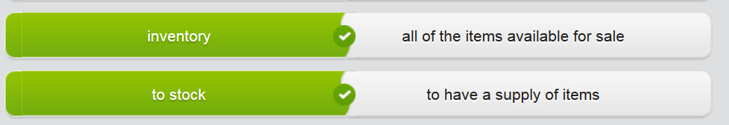

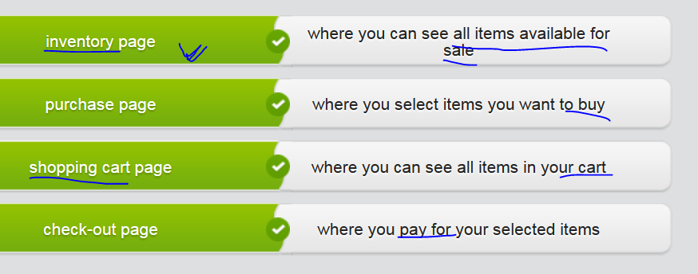

* exquisite /ɪkˈskwɪzɪt, ˈɛkskwɪzɪt/, exquisitely, exqui’siteness (n) 精美

1. ADJ Something that is exquisite is extremely beautiful or pleasant, especially in a delicate way. 精美的精致的 **[ 精美的礼物exquisite gift; 精美的珠饰: exquisite diamond; exquisite gem]** e.g. The Indians brought in exquisite beadwork to sell. 印地安人带了精美的珠饰来销售。 ...exquisitely crafted dollshouses. …制作精美的玩具小屋
2. intense or sharp 强烈/剧烈的 suffer exquisite pain 剧烈的疼痛   ;   felt exquisite pleasure 强(烈)的 舒适
3. lavishly elegant and refined 优雅 的
4. 精致的；优美的of extreme beauty **[精致的面容 exquisite face]** e.g. OMG, WuSehun is so handsome, with such an **exquisite face (精致的面容)** . e.g. Undoubtedly, AngelaBaby has such an **exquisite/ ɪkˈskwɪzɪt/ face**; however, her acting skills are blamed a lot.

* Seal, reseal sth e.g. Then, when you’re done watching the movies, you put them back in the return envelopes, which you can easily **reseal**  再密封；重新封装, and put in the mail **without having to buy stamps!**
* **mom-and-pop  ['mɔmənd'pɔp]** adj. small and privately-owned business 夫妻经营的；家庭经营的; 小型的(商店,生意) **[ mom-and-pop business; mom-and-pop hotel; mom-and-pop store]**
* thumbnail image

e.g. you can easily see that when you hold your cursor over the **thumbnail image** for the movie, you get basic information about the movie; when you click on it, you get even more information.

* Brick-and-mortar location/store; brick-and-mortar business

mortar /ˈmɔːtə/ 1. A mortar is a big gun that fires missiles high into the air over a short distance. 迫击炮 e.g. The two sides exchanged fire with mortars and small arms. 2 Mortar is a mixture of sand, water, and cement or lime which is put between bricks to hold them together. 灰浆 e.g ..the mortar between the bricks …砖块间的灰浆 [ brick and mortar 实体的； 实体店铺 a brick and mortar store; 实体(的)商业模式: brick and mortar business model ] //mason ['meɪs(ə)n] 泥瓦匠 V.S. mansion ['mænʃ(ə)n]大厦；宅邸

eg You can use Touch ID to unlock your iPhone, but you can also use it to pay for goods and services using Apple Pay in **brick and mortar stores实体店** or in the online shops. **With the advent of** e-commerce, there is a lot of growth opportunity for businesses that create a **web presence (web 平台提供商**).

e.g **With the advent of** online businesses, more and more **brick-and-mortar stores实体店**, esp. the **mom-and-pop stores** 小型的商店, have **gone bust/gone bankrupt** or are endangering.

e.g. The trend is leaving some small businesses asking whether the traditional **brick-and-mortar business model** 实体(的)商业模式 is out of date. Will **brick-and-mortar businesses** 实体商业be profitable in the future as more and more people begin to buy online? The answer is almost always yes. The **brick-and-mortar location** still has and will continue to have value. In addition to any profits the location makes from **walk-in customers**, it offers your business brand exposure and serves as a **warehouse** where the **inventory** you offer online is stored, packed and shipped. Statistics also shows that multichannel retailers, those that have both a **brick-and-mortar location** and an online business, have higher online retail profits and growth than online-only businesses.

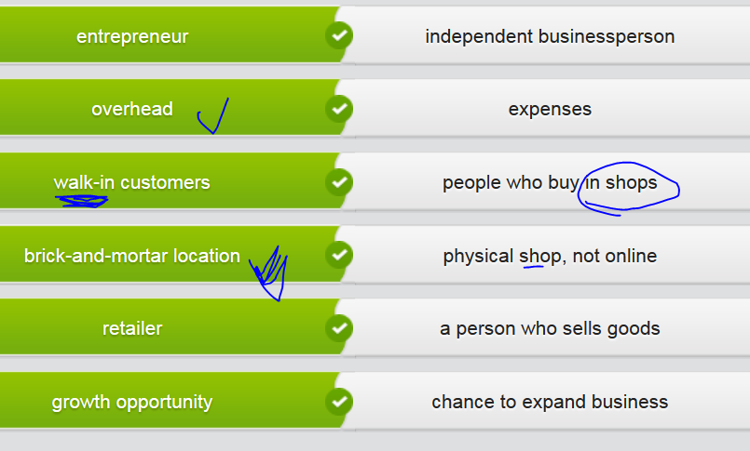

## mp3Done) Video) Online retailor e.g. Amazon, TaoBo, Jingdong





**With the advent/ˈædvɛnt/of** the internet随着(computer/smartphone)的出现, **though**, companies have tried to **harness** the power of this new method of communication to sell their products.



In the 21st century, e-commerce ( that is shopping online instead of in the brick-and-mortar stores ) is definitely one of the most **sought-after 受欢迎的，很吃香的**ways of doing business.

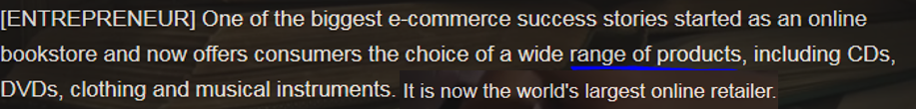 * enticing: extreme attractive 诱人的 * inventory: a list of all products that are available to sale











 * **intuitive直觉的**



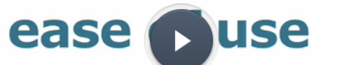









* Overheads = expenses V.S. outlay  (必要的) 费用 * negative sides = downsides 消极面，缺点











* 声誉好的 reputable ['rɛpjətəbl] V.S. disreputable/notorious
* identity theft: your confidential personal details, such as credit card information, are stored by **scammers/scam artist** who use your personal information to **commit business fraud/shenanigan**.



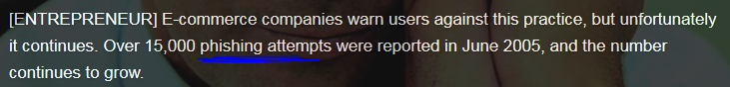





## 2nd row) Online shop V.S. brick and mortar shop实体店

## Reading: The benefits of developing a web presence

As consumers have become more comfortable shopping online, retail sales online have increased. According to the U.S. Census **Bureau**, online retail spending has been steadily increasing since 2000 and **is projected to** hit 165.9 billion dollars in 2009. And there’s reason to believe that such **figures** are not overly **optimistic**: Online retail sales grew by 6 percent in 2008, despite the weak economy.

**At this point**, all major retailers in the U.S. already have **an online presence/web presence (web在线平台**). When their products are suitable for purchase and distribution from an online retail shop, these major retailers have pursued retail sales online. They will certainly profit from the increase in online sales in the years to come, but this increase may come with a decrease in sales at their many **brick-and-mortar locations** across the country. These locations could continue to carry the same **overhead／恶性喷色** without making the same profit. But for new entrepreneurs and small businesses, the trend offers a tremendous **growth opportunity**. These businesses can increase their base of potential customers, though they generally only have one brick-and-mortar location.

The trend is leaving some small businesses asking whether the traditional **brick-and-mortar business model** is out of date. Will **brick-and-mortar businesses** 实体商业be profitable in the future as more and more people begin to buy online? The answer is almost always yes. The **brick-and-mortar location** still has and will continue to have value. In addition to any profits the location makes from **walk-in customers**, it offers your business brand exposure and serves as a **warehouse** where the **inventory** you offer online is stored, packed and shipped. Statistics also shows that multichannel retailers, those that have both a **brick-and-mortar location** and an online business, have higher online retail profits and growth than online-only businesses.

Clearly, the online retail trend is here to stay. Profit will remain the greatest benefit small businesses can achieve by developing a Web presence.

## Sentences related to online retailer V.S. brick-and-mortar location

A small business with a **brick-and-mortar location** could profit from an **online retail shop.**

I'm interested in how this new **business model** will develop in the future.

I think that it could be profitable for retailers , as consumers are increasingly buying online.

Many people project that online sales figures will continue to increase.

There is a lot of growth opportunity for businesses that create a **web presence (web 平台提供商**).

Statistics show that this trend is here to stay.

## 3rd row Reviewing an e-commerce site (e.g. Amazon, jingdong)

**Reviewed by Anna J.:**

I love **Amazon’s** website. Besides the nice GUI view of **inventory** (a list of all products that are available to sale), **my favorite things about it are the book reviews and recommendations**. I’m sure that publishers and authors write nice reviews, **preface**序, and recommendations for their books, but I think most of the people writing about the books are average readers.

In the reviews, they say whether they liked or dislike about the book with reasonable comments and even solid evidences sometimes, **then rated it.** The Amazon website calculates the average rating for each book, so you can easily see even before reading the book reviews how many people have recommended a book. The book recommendations are lists of books that people create. For instance, a reader might start a list of books about history that they recommend. These reviews and recommendations really help to bring books that interest me to my attention.

Additionally, the delivery speed is so quick that it can reach you within 24 hrs.

**Reviewed by Ethan R.:**

I like **Amazon** because of its huge choice, with the amazing **inventory (a list of products that are available for sale)** for you to browse. You can find just about any book there, and that’s good for me since I like to read **science fiction** books that are really difficult to find in book stores. I also often buy books for my friends and family who like to read **unusual books**. For instance, my sister is always looking for really old English books that aren’t being printed anymore. If I can’t find new copies of these books for her on Amazon, I can at least find a used copy through one of the used book sellers working with Amazon.

Additionally, the delivery speed is so quick that it can reach you within 24 hrs.

**Reviewed by Jana X.:**

I think **Netflix (online TV)** is great **because of its ease of use**. There is a lot of information about movies there, including details about the story and its **rating**, and you can create a list of movies you’d like to see and specify when movies are sent to you. But despite there being a lot of functionality, you never have to take much time **figuring out** what is going on. For instance, you can easily see that when you hold your cursor over the **thumbnail image** for the movie, you get basic information about the movie; when you click on it, you get even more information. It’s also clear that you can browse different types of movies, a list of the most popular movies or what your friends have been watching. It’s just so easy!

**Reviewed by Tim M.: ( Netflix is a pretty good e-commerce site)**

**Netflix** appeals to me since **it’s so convenient**. You don’t have to go to the video rental shop (that is the **brick-and-mortar location实体店**) to get a movie; you just order it from the company’s website, then either watch it online or have it delivered to you. Unlike the movie rental shop**,** you never have to **wait in line for ages 等很久** and, if they’re in Netflix’s **inventory ( a list of all products that are available to sale)**, the movies you want to see are always available.

The best point is when you’re done watching the movies, you put them back in the return envelopes, which you can easily **reseal** 再密封/重新封装, and put in the mail **without having to buy stamps!** The website also recommends movies you might like and provides more information about each movie. Now that’s convenience!

## 4th row) Choosing an e-commerce site, e.g Amazon, Jindong

You're buying a gift for a business client and want to shop online. Your gift budget is $100. Read the reviews of the four different online gift shops and then choose the best website. => For me, I’ll buy business related books from Amazon. Amazon provides nice list of books upon review, recommendation, and ratings – see the Amazon on-line shopping topic above.

|  |
| --- |
| **Tracy**  InABow.com is the place for a huge selection of gifts for your significant other. Literally, you can find anything that 'special someone' might desire – chocolates, clothing, even romantic getaways. For example, I usually buy the beautiful box of 48 fine, dark Alexandrine Chocolates for my husband, but they would make a suitable gift for any occasion. Now, last year for our anniversary, I bought a trip to Nova Scotia. It was a great deal, and InABow even suggested an unusual travel itinerary. I was so impressed! InABow is sure to help you keep romance alive! |
| **STorres** |
| Thanks, LanaL! I'll be sure to check out **InABow, but it sounds best for gifts of love**, right? I'm looking for reviews of gifts for any occasion. I still haven't found a good place. All I can say Gifty.com can be frustrating. The shipping service is lacking. I ordered a beautiful, Italian silk tie for a business client – the colors were **exquisite**/ɪkˈskwɪzɪt, ˈɛkskwɪzɪt/ 精美的. They even offered free gift-wrapping with every purchase of $50 or more. I was certain my client would appreciate this fine gift. Unfortunately, I wanted to give the tie one week later, but it took eight weeks to ship. I decided it was OK to wait, but when I finally got the gift and presented it to my client, it was the wrong tie – a horrible orange and purple blend that would be best worn in the dark**. What a disaster!** Customer service agreed to ship the correct tie. It's now three weeks later, and I still don't have the right tie. |
| **LonelyLogan** |
| I think SurpriseSupplies.com is pretty cool because of the user gift suggestions. You enter the type of gift you're looking for **and your relationship with the person you're giving to**. So, for example, you might enter 'graduation' and 'daughter.' Hit 'submit,' and you'll get dozens of ideas from actual users about what to give. Click on something a user recommends, and the site takes you directly to a page where you can purchase the item. So, I bought a tablet for my daughter, but you **can find something for anyone.** They even have specialty categories, like 'Romance' and 'Business.' Also, a friend of mine in IT told me that their site security is one of the best, so I don't worry about **identity theft**, that is having my personal information stolen. My only complaint is that a lot of the gifts are rather expensive, but you can usually find something for under $50, too. |
| **Angga123** |
| InABow sounds pretty good. Missippi.com has free, two-day shipping, so I frequently bought gifts for my colleagues there. The selection is fantastic, the recommendations are helpful, and they even allow you three free food deliveries a month from participating local restaurants. I won't shop there anymore, though, because someone, obviously a **scammer**, charged more than $1,000 at Missippi.com to my credit card after the account was **phished**. Missippi.com won't help me at all with the case. |

# Part 3) Complain a lost delivery that is from an online retailer

## 1st row

## Stop) Lexical resource

sticking point  V.S. turning point

1.N-COUNT A sticking point in a discussion or series of negotiations is a point on which the people involved cannot agree and which may delay or stop the talks. Asticking point is also one aspect of a problem which you have trouble dealing with. 症结; 难点

例：

The main sticking point was the question of taxes.

主要的症结是税收问题。

vibrant /ˈvaɪbrənt/  TEM4

1.ADJ Someone or something that is vibrant is full of life, energy, and enthusiasm. 充满活力的 [ vibrant nightlife in SH ] e.g. Tom felt himself being drawn toward her vibrant personality. 汤姆感到自己正被她充满活力的个性所吸引。

...Shakespeare's vibrant language.

…莎士比亚那充满活力的语言。

2.N-UNCOUNT 活力 vibrancy

例：

She was a woman with extraordinary vibrancy and extraordinary knowledge.

她是一个活力四射、知识渊博的女性。

3.ADJ Vibrant colours are very bright and clear. (色彩) 鲜亮的 [ vibrant vivid green; vibrant color ]

例：

Horizon blue, corn yellow and pistachio green are just three of the vibrant colours in this range.

天际蓝、玉米黄和淡草绿只是这一色域中的3种鲜亮色彩。

4.ADV 鲜亮地 vibrantly

例：

...a selection of vibrantly coloured French cast-iron saucepans.

…一套精选的色彩鲜亮的法国铸铁炖锅。

* dread /drɛd/, **dreadful/awful/terrible; dreadfully=terribly, awfully糟糕透了**

1. V-T If you **dread something** which may happen, you feel very anxious and unhappy or **you have a phobia about it** because you think it will be unpleasant or upsetting害怕; 担忧 e.g. I'm **dreading Christmas** this year. 我害怕今年的圣诞节。E.g. I’m **dreading coming** back and living with my mum, to be honest. 我很害怕回来。 = **have a phobia about/fear of sth => phobia, phobic**

2.N) Dread is a feeling of great anxiety, fear or **phobia** about something that may happen. 忧虑; 恐惧 e.g. She thought with **dread** of the cold winters to come. 想到寒冬即将到来，她就感到恐惧。

3. If you say that you **[ dread to think ]** what might happen, you mean that you are anxious about it because it is likely to be very unpleasant. 很怕想xxx,不敢想xxx e.g. I **dread to think** what will happen in the case of a major emergency. **我不敢想像** 万一出现重大紧急情况会怎么样 V.S. **Just DARE to think 只要敢想**

V.S. **It’s inconceivable that xxx 难以置信的; 难以想象**

* dreadful/awful/terrible; dreadfully=terribly, awfully糟糕透了**[ I’m terribly sorry = I’m dreadfully sorry]**

Gardening supplies (园艺):

* **喂鸟器 bird feeder:**  A bird feeder is an object that you fill with seeds or nuts and hang up outside in order attract birds.
* **花盆 flower pot:** a container in which plants are **cultivated** (培养，培育; 耕作)
* **尤指室内)盆栽植物, e.g.肉肉 pot plant:** a plant that grows in a flower pot, esp indoors
* **盆栽土 potting soil**
* **牧草种子；草籽: grass seed**
* **连夜快递(东西) overnight sth to sb.**   
  e.g. One week isn't good enough. That’s unacceptable. I'd like you to **overnight a replacement to me**.
* **reimburse /ˌriːɪmˈbɜːs/**

1.V-T If you **[ reimburse someone for something ],** you pay them back the money that they have spent or lost because of acceptable reasons. 报销; 偿还 e.g. I'll be happy to **reimburse *you* for any expenses/overheads** you've had. 我很乐意报销你的所有花费

reimbursement /ˌriːɪmˈbɜːsmənt/

1.N-VAR If you receive reimbursement for money that you have spent, you get your money back, for example because the money should have been paid by someone else. 报销; 偿还 e.g. I'd like to ship the items back **free of charge** and receive full **reimbursement**报销; 偿还 e.g. She is demanding **reimbursement for** medical and other expenses/**overhead**. 她在要求医疗和其他费用的报销

* exotic: /ɪɡˈzɒtɪk/, exotically, exoticism (常因来自遥远的他国而显得) 异国的；外来的；异国情调的 1.ADJ Something that is exotic is unusual and interesting, usually because it comes from or is related to a distant country. **[ exotic attire 异国情调的衣服; exotic life style 异国的生活]**  e.g. ...brilliantly coloured, exotic flowers. …色彩绚丽的奇异花卉。2.ADV 奇异地e.g. ...exotically beautiful scenery. …奇异美景   
  e.g. If you just want to add some shine to your resume, or taste **the exotic life**/ɪɡˈzɒtɪk/, **it's not worth your time and cost** / it’s not **worthwhile**. 或是想体会异国的生活，这个代价未免太大了。
* **exoticism /ɪɡˈzɒtɪˌsɪzəm/ n) 异国风味/ 情调；洋派** Exoticism is the quality of seeming unusual or interesting, usually because of associations with a distant country. 异国情调   
  e.g. This fancy restaurant is full of strong **exoticism**.   
  E.g. He was born in LA, so his communication style is full **of** **exoticism**洋派. Compared with local Chinese who are used to chatting with **hedges (“like”, “maybe”, “it seems”)** to avoid directness, he likes to communicate straightforwardly, mostly **calling a spade a spade**直言不讳/实话实说 **(spade铲子, 黑桃牌)**
* exquisite /ɪkˈskwɪzɪt, ˈɛkskwɪzɪt/, exquisitely, exqui’siteness

1. ADJ Something that is exquisite is extremely beautiful or pleasant, especially in a delicate way. 精美的精致的 **[ 精美的礼物exquisite gift; 精美的珠饰: exquisite diamond; exquisite gem/gemstone宝石]** e.g. The Indians brought in exquisite beadwork to sell. 印地安人带了精美的珠饰来销售。 ...exquisitely crafted dollshouses. …制作精美的玩具小屋
2. intense or sharp 强烈/剧烈的 suffer exquisite pain 剧烈的疼痛   ;   felt exquisite pleasure 强(烈)的 舒适
3. lavishly elegant and refined 优雅 的
4. 精致的；优美的of extreme beauty **[精致的面容 exquisite face]** e.g. OMG, WuSehun is so handsome, with such an **exquisite face (精致的面容)** . e.g. Undoubtedly, AngelaBaby has such **an exquisite /ɪkˈskwɪzɪt/ face**; however, her acting skills are blamed a lot.

* **obscure /əbˈskjʊə/ = rare**1. If sth or sb. is obscure, they are unknown, or are known by only a few people. 鲜为人知的(故事，历史，东西，书籍，人) e.g. The origin of the custom is **obscure**. 该习俗的起源鲜为人知。  
  2.ADJ Something that is **obscure** is difficult to understand or deal with, usually because it involves so many parts or details. 复杂难懂的; 难处理的(东西)   
  e.g. The contracts are written in **obscure** language. 那些合同是用**复杂难懂的**语言写的。 E.g. It’s a big challenge to be an ID for DP project because DP product is **obscure** to handle.  
  3.V-T If **one thing obscures another**, it prevents it from being seen or heard properly. 遮掩  
  e.g. Trees **obscured his vision**; he couldn't see much of the square's southern half. 树木遮住了他的视线。  
  4.V-T To obscure something means to make it difficult to understand. 使…难懂 e.g. ...the jargon that frequently obscures educational writing. …常使教学行文变得复杂难懂的术语
* tin /tɪn/    
  1. Tin is a soft silvery-white metal. 锡 **[ smelt tin 熔炼锡 ]** e.g....a factory that turns **scrap metal 废金属** into tin cans. …一个将**废金属**制成锡铁罐的工厂。   
  2. A tin is a metal container with a lid in which things such as biscuits, cakes, or tobacco can be kept. 金属罐 e.g. Store the biscuits in an airtight tin. 把这些饼干存放在一个密封的金属罐里
* smelt /smɛlt/ to extract a metal from an **ore[ɔr] 矿石** by heating 熔炼(矿石).   
  E.g. The native people learned how to **smelt tin and copper** – a procedure **whereby/by which** the two **ores [ɔr] 矿石** are melted together to form a bronze **alloy/ˈælɔɪ/ 合金**.
* alloy /ˈælɔɪ/  An alloy is a metal that is made by mixing two or more types of metal together. 合金 Bronze is an alloy of copper and tin. 青铜是一种铜锡合金 E.g. The native people learned how to **smelt tin and copper** – a procedure **whereby/by which** the two **ores [ɔr] 矿石** are melted together to form a bronze **alloy/ˈælɔɪ/ 合金**. V.S. 小巷；小路 alley = lane
* foster /ˈfɒstə/

1.ADJ Foster parents are people who officially take a child into their family for a period of time, without becoming the child's legal parents. The child is referred to as their foster child. 收养的 E.G. Little Jack was placed with **foster parents**. 小杰克被安置在 **养父母家**。 V.S. **biological parents 生父母**

2.V-T If you foster a child, you take it into your family for a period of time, without becoming its legal parent. 收养 e.g. She has since gone on to find happiness by **fostering** more than 100 children. 她此后又通过收养一百多个孩子找到了快乐。

3.V-T To foster something such as an activity means to help it to develop. **促进(经济; 活动；发展)　[促进全球经济增长 foster global economic growth ]**e.g. He said that developed countries had a responsibility to **foster global economic growth** to help new democracies. 促进全球经济增长 以帮助新兴民主国家的责任

* civilization /ˌsɪvɪlaɪˈzeɪʃən/

1.N-VAR A civilization is a human society with its own social organization and culture. **文明社会; 文明古国。** E.g. The ancient civilizations of Central and Latin America were founded upon corn. 中美洲和拉丁美洲的古代文明社会是建立在玉米之上的。

2.N-UNCOUNT Civilization is the state of having an advanced level of social organization and a comfortable way of life. 文明 e.g. ...our advanced state of civilization. …我们高度的文明形态。

* gunpowder /ˈɡʌnˌpaʊdə/

Gunpowder is an explosive substance that is used to make **fireworks** or cause explosions. 火药

* e-money: e.g. In this day and age, we must diversity payments not only in brick-and-mortar store, but esp. for online business, the diversification of payments include the most prevalent zhifubao, weichat, apple pay
* 冒着生命，押上性命**risk life and limb**: e.g. The War Wolf, one of the best blockbusters一鸣惊人者 in Chinese movie industry, is filmed by Wujing who **risked life and limb.**
* astrology /əˈstrɒlədʒɪ/, astrological   [,æstrə'lɔdʒik;-kəl] 占星学的，占星术的; 占星家astrologer [ə'strɔlədʒə]

Astrology is the study of the movements of the planets, sun, moon, and stars in the belief that these movements can have an influence on people's lives. 占星学

占星家astrologer [ə'strɔlədʒə]: someone who predicts the future by the positions of the planets and sun and moon

* astronomy [ə'strɔnəmi], astronomical **[,æstrə'nɑmɪkl],** astronomer /əˈstrɒnəmə/天文学家,

the branch of physics that studies celestial bodies and the universe as a whole

astronomer /əˈstrɒnəmə/: An astronomer is a scientist who studies the stars, planets, and other natural objects in space. 天文学家 =>

* [,æstro'fɪzɪks] astrophysics　天体物理
* Venture /ˈvɛntʃə/

1.N-COUNT A venture is a project or activity that is new, exciting, and difficult because it involves the risk of failure. 风险项目; 冒险活动 e.g. **All extreme sports** are ventures.

2.V-I If you venture somewhere, you go somewhere that might be dangerous. 冒险去 (某处) e.g. People are afraid to venture out for fear of sniper attacks. 人们不敢冒险外出，害怕狙击手的袭击。

3.V-T If you **venture a question or statement,** you say it in an uncertain way because you are afraid it might be stupid or wrong. 试探地提出 (问题或观点); 小心地问问题

e.g "So you're Leo's girlfriend?" he **ventured.** “那么你就是利奥的女朋友了？”他小心地问道。  
e.g "Don't ask," he said, whenever Ginny **ventured to raise the subject**. 每当金尼 **冒险试探着提起这个话题**时，他总是说∶“你不要问了。”

e.g. He **ventured that** plants draw part of their nourishment from the air.

他 **试探着提出**了 <植物从空气中吸取它们的部分养分> **的观点**。

4.V-T If you **venture to do something** that requires courage or is risky, you do it. 冒险 (做某事) e.g.

5.V-I If you venture into an activity, you do something that involves the risk of failure because it is new and different. 冒险 (从事活动) e.g. He enjoyed little success when he ventured into business. 他在冒险涉足生意时很少成

* **[ barter A for B ]** /ˈbɑːtə/ ; **barterer**

1. If you barter goods, you **exchange** or **swap** /swɒp/ them for other goods, rather than selling them for money. 以物交换; 以物易物 e.g. They have been **bartering wheat for cotton and timber**. 他们一直在用小麦交换棉花和木材。 E.g. The market-place and street were crowded with those who'd come to **barter**. 市场和街道上挤满了来进行物物交换的人。

2.N Barter is also a noun. 物物交换 e.g. Overall, **barter** is a very inefficient means of organizing transactions. 总的说来，物物交换是一种非常低效的组织交易的方式。

**barterer** ['ba:rtərər]: a trader who exchanges goods and not money

* **swap** /sw**ɒ**p/  If you swap something with someone, you give it to them and receive a different thing in exchange. 交换 [ [interest rate swap](javascript:void(0);)利率互换; [credit default swap](javascript:void(0);)信用违约交换; [currency swap](javascript:void(0);) [经]货币套换；互惠外汇信贷 ]

e.g. Next week they will swap places and will repeat the switch weekly. 下周他们将互换位置，以后将每周换一次 2.N-COUNT Swap is also a noun. 交换 e.g. Over the long term, a swap of some kind is clearly in the public interest. 从长远看，有点交换显然是为了公共利益。

3.V-T If you swap one thing for another, you remove the first thing and replace it with the second, or you stop doing the first thing and start doing the second. 调换 e.g. Despite the heat, he'd swapped his overalls for a suit and tie. 尽管天气炎热，他还是把他的工装裤换成了西装和领带。

## mp3 Done) video) Ancient trade ( e-commerce is a new type of trade)

e-money: e.g. zhifubao, weichat, apple pay



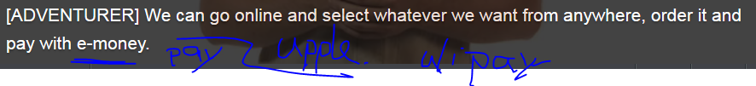

 











tin /tɪn/ 1. Tin is a soft silvery-white metal. 锡 ; 2 A tin is a metal container with a lid in which things such as biscuits, cakes, or tobacco can be kept. 金属罐

smelt /smɛlt/ 1.V to extract (a metal) from (an ore) by heating 熔炼 **[ smelt tin 熔炼锡 ]**

alloy /ˈælɔɪ/  An alloy is a metal that is made by mixing two or more types of metal together. 合金 Bronze is an alloy of copper and tin. 青铜是一种铜锡合金

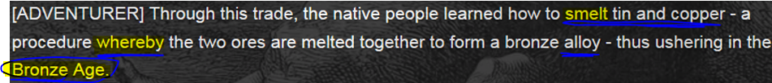

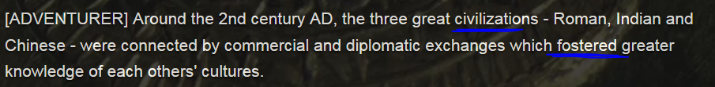

* foster /ˈfɒstə/ 1. 收养 ; 2. To foster sth means to help it to develop. 促进(经济,发展,一个活动) He said that developed countries had a responsibility to **foster global economic growth** to help new democracies
* a gem or gemstone is a jewel or stone used in jewellery. 宝石; * barter A for B, barterer物物交换



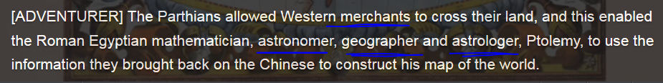





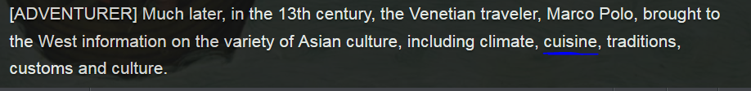

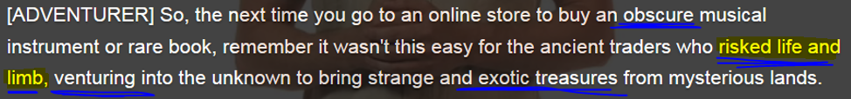

* 冒着生命，押上性命risk life and limb * obscure: 鲜为人知的 (history, story)； 复杂难de
* exotic: /ɪɡˈzɒtɪk/  异国的；洋气的；异国情调的 exotically, exoticism [ɪɡ'**zɑtɪsɪzəm**]

## mp3 Done) 3rd tab) video



## 2nd row) Report/explain the problem and complain about a product you’ve bought through e-commerce (online, by internet)

* E-commerce: buying or selling goods over the internet, not in the **brick-and-mortar store/location**.

When you report a problem with a product to the seller, you should explain the problem. You can then ask for a solution.

* **I'm calling to report a problem with a purchase/my order**. The chair I ordered came with a small hole in the seat. Could you explain how to return it?
* **I wanted to let you know about a problem with my purchase/order**. I've been waiting for my new TV for three weeks. Can you track the order?
* **There's a problem with the pants I ordered** – they're the wrong size. Is there some way I can exchange them for **the next size up**?

Sometimes, you may be disappointed or shocked at the poor quality of a product sold by a company with a good reputation. In this case, you may want to convey your reaction with the **intonation** you use. Listen to the disappointment or shock as people report the following problems.

* Don't you have some kind of policy to guarantee the quality of your products?
* Don't you have a policy on the quality of your flowers?
* Aren't you supposed to **specialize in** top-quality **customer service**?
* Aren’t you supposed to **specialize in** sth? 你们难道不应该在xxx方面是专长的吗？
* Aren't you supposed to **specialize in** top-quality cars?

|  |
| --- |
|  |

## Mp3 done) video: Report and complain a product you bought



## 3rd row) Complain about a product you’ve bought through e-commerce (online, by internet)

Use expressions like these to **indicate you are calling or writing to complain about a purchase that was shipped to you.**

* Hi, I'm calling to complain about a recent order.
* I'm writing because I need your help resolving a problem.

Use expressions like these **to explain the nature of the complaint.**

* There's something wrong with the mouse pad.
* This is completely unacceptable
* Another complaint – I'm not happy with your **customer service**.

Notice the relative subtlety in the way these complaints are worded, although **intonation** may indicate obvious **dissatisfaction**. The customer is indirectly saying the order took too long to arrive.

* I had to call to have my order tracked.
* The order finally arrived, but there's a big problem.
* I'd like to point out that the order took two weeks to get here.

Use expressions like these to **suggest a resolution for the problem**:

* Could you explain how to return it?... well, I'd like to ship the items back **free of charge** and receive full **reimbursement**报销; 偿还.
* One week isn't good enough. That’s u**na**cceptable. I'd like you to **overnight a replacement**连夜快递 to me.
* The only resolution I can see is not to do business with you.
* Is there some way I can exchange them?

## Mp3 done) video: Making complaints about a product you purchased.



Listen to the audio. A customer has called to complain about four items she ordered online and is not satisfied with.

## Mp3 done) video) 4th row) Tracking a lost delivery

You ordered equipment two weeks ago from computercrazy.com but there were problems: 1) You got a mouse pad instead of a mouse. 2) The keyboard was broken. 3) The monitor never came. You phoned last week and were told the items would be tracked, but you've heard nothing since then. Get replacements or your money back (reimbursement).

# Part 4 ) Describe an e-commerce site (e.g. Amazone)

## STOP 1st row

## Stop) Lexical resource

* blurb /blɜːb/  
  The blurb about a new book, film, product, a new feature of DP7601, or exhibition is information about it that is written in order to attract people's interest for propagation. (新商品/产品特性信息)推介, 大肆宣传；吹捧性(商品)广告 e.g. Can you please just write some **blurb** for your GWS feature in rel7601 “What’s new”.
* 令人印象极深刻的; 令人极震惊的 mind-blowing = extremely impressive or surprising  
  if you describe something as mind-blowing, you mean that it is extremely impressive or surprising. e.g. The War Wolf, one of the most **sought-after** blockbuster movies in CHINA, is quite **mind-blowing.**
* the sheer volume of sth总量  
  e.g. I use Muzing.com for all my music needs. The unlimited streaming subscription is 9.99 bucks a month, and you can also purchase music from muzing.com for yourself or as gifts for others. **The sheer volume 总量of** music they have is **mind-blowing (extremely impressive or surprising)** – there are more than 20 million **tracks**, so it’s easy to find the music you love, and discover cool new tunes, too. Another highlight is that they allow you to keep 3000 **tracks** in storage on your device so that you can listen to music offline.  
  e.g. But no matter how hard African governments try, they cannot cope with **the sheer volume of** the new enterprises.    无法应对新企业数量的**绝对增长**  
  e.g. Still, **the sheer volume of** pollutants, including benzene, means they pose a real risk.  
  e.g. **The sheer volume of** oil that's out there has to mean there will be some verysignificant impacts,

V.S.

* propagate /ˈprɒpəˌɡeɪt/ , N)  ['prɑpə'gændə]  n. 宣传；传道总会

1.V-T If people propagate an idea or piece of information, they spread it and try to make people believe it or support it. 宣传 e.g. They propagated political doctrines that promised to tear apart the fabric of society. 他们宣传有可能摧毁社会结构的政治学说。

2.N-UNCOUNT 宣传 propagation e.g. These two countries must work together toward the propagation of true Buddhism. 佛教教义的宣传。

3.V-T If you **propagate plants**, you grow more of them from the original ones. 繁殖(植物) e.g. The easiest way to **propagate a vine** is to take hardwood cuttings. **繁殖**葡萄藤(vine)最容易的就是采取硬木扦插

* Diverse, diversity; diversify sth; diversification  [dai,və:sifi'keiʃən; di-]  
  diversification  [dai,və:sifi'keiʃən; di-]: 商业】(投资的)经营多样化，多样化的经营; 2.

(一地区企业)布局多样化; 多样化，形形色色

Warehouse: if we c

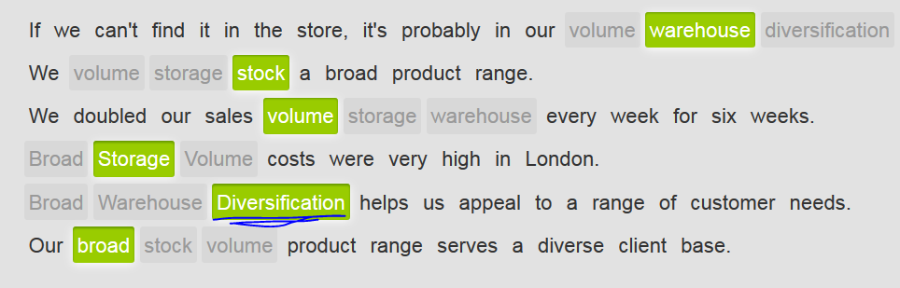

* resort /rɪˈzɔːt/

1.V-I **不得不**求助xxx If **you resort to** a course of action that you do not really approve of, you adopt it because you cannot see any other way of achieving what you want. **[ V resort to sth; resort to doing sth ]** eg. In APIC, we’ve **resorted to using** the readAsBuffer() API to deal with the payload issue because … . E.g. His punishing work schedule had made him **resort to drugs**. **不得不**求助于(毒品)了。  
V.S. [**have recourse t**o](javascript:void(0);)求助于 e.g. I **had recourse to** Google map and finally got my location.

2.N) If you achieve something without resort to a particular course of action, you succeed without carrying out that action. To **have resort to** a particular course of action means to have to do that action in order to achieve something. **诉诸(武力,法律) /不得不求助(武力,法律)**e.g. Congress has a responsibility to ensure that all peaceful options are exhausted before **resort to war**. 之后再**诉诸武力/不得不求助武力,**。

3. 孤注一掷的行为; 最后的办法, 最后手段 If you **do something as a last resort,** you do it because you can find NO other way of getting out of a difficult situation, **predicament** 窘况，困境, or of solving a problem.   
V.S. **[ the last straw 终于使人无法忍受的最后一击；压断了xxx的最后一根稻草, 导火线 ]**

e.g. Nuclear weapons should be used only as a last resort. 核武器应该只被用作最后手段。

4.N-COUNT A resort is a place where a lot of people spend their holiday. (度假) 胜地 e.g. The ski resorts are expanding to meet the growing number of skiers that come here. 该滑雪胜地正在扩建以应付来这里滑雪的不断增长的人数

* likewise /ˈlaɪkˌwaɪz/  CET4 TEM4

1.ADV You use likewise when you are comparing two methods, states, or situations and saying that they are similar. 同样地 e.g. And, would it be a viable product?  I think we have a chance for this, but let me lay it out and ask that you all review it, and stand up, if you feel that there are things that can not make the date.  Likewise please check for things that are omitted. E.g. What is fair for homeowners likewise should be fair to businesses.

对私房业主公平的，同样也该对商家公平。

2.ADV If you do something and someone else does likewise, they do the same or a similar thing. 照样地

例：

He lent money, made donations and encouraged others to do likewise.

他把钱借出、捐出，并鼓励其他人这么做

## 2nd row) Qualities of online customer service

Complain about the customer service: e.g. I’m not satisfied with your customer service.

* Aren't you supposed to **specialize in** top-quality **customer service**?
* Aren’t you supposed to **specialize in** sth? 你们难道不应该在xxx方面是专长的吗？
* Aren't you supposed to **specialize in** top-quality cars?

**The quality of online customer service:**

1. Good **website usability** is one of our two top priorities. If the website isn’t easy to use and reliable, the customers won’t make purchases.

* Good **website usability** makes it easy for customers to shop online.

2. Selling only high-quality products is the second of our two top priorities. If quality is low, customers won’t come back.

3. A broad **product range** is essential. We need to offer our customers a selection. Providing a well-arranged **inventory** for users is necessary.

* Customers want selection, so we offer a broad **product range.** We attract many types of customers because of the **diversity** of our products

4. **Diverse** **payment and delivery options** are important. We don’t want to lose customers who may need to pay for or receive goods in ways that we’re not accommodating. In this day and age, **diversify** the online payment is rather necessary, e.g. we support various types of **e-money payment,** including the most **prevalent**盛行zhifubao and apple pay.

* We attract many types of customers because of the diversity of our products

5. We need to continue to understand our customers’ needs. What are they looking for when they come to us? Let’s make sure they always find it!

6. Let’s continue to provide some of the best customer service and **technical support** in the industry. Our goal is to quickly resolve every issue with our products or website with a friendly **professionalism**.

* If you have questions about using the website, give our technical support a call.

7. Don’t forget the importance of **product knowledge** in customer service. Know the details about the products we sell.

* Our customer service personnel have excellent **product knowledge** .

8. 薄利多销We need to sell at a high **volume** in order to continue offering low prices.

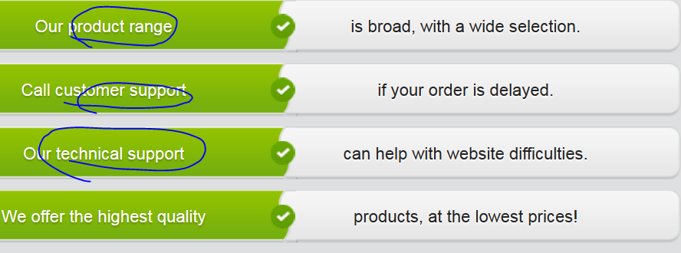

## 3rd row) Comparing products – using “**comparative sentence**”

**Use Venn diagram to compare A and B. Object A V.S. object B: whole-to-whole; point-to-point; similarities-to-difference. For details about Venn diagram, see the unit “Education and training” .**

Hello Sally,

How are you? I just want to write quickly to tell you that those shoes you saw in the mall are on sale on the store’s website! So they’re cheaper online than in **the brick-and-mortar location/store**. Actually, they have such good online deals, I just bought myself a pair. They’re more expensive than the first pair I liked, but I like them better.

Best, Jenny

________________________________________________________

Hi Jenny,

Thanks for letting me know! Actually, they’re not the exact same shoes, but they’re better than the pair in the **the brick-and-mortar location/store**. The heel is a little higher than the heel on the ones we saw. So I bought them! I think I know which pair you bought. They’re the black ones with the **buckle**带扣, right? They’re more interesting than the ones we saw in the store.

Hugs, Sally

____________________________________________________

Hey Sally,

The only problem is, getting them from the store is speedier than getting them online. I hate having to wait a week for them to be delivered. That said, the **customer servic**e people online are a lot friendlier than the people in the **the brick-and-mortar location/store**. I had to call them about sizes, but they **sorted everything out** and were really nice.

Best, Jenny

____________________________________________________

Hi Jenny,

It’s too bad they’re not as friendly in the **the brick-and-mortar location/store** as they are in the online customer service. Luckily shopping online is almost as much fun as going to the mall. Anyway, I showed my roommate the shoes online, and she thinks they look the same as the ones in the store. Oh well…. I’ll let you know when they arrive!

Hugs, Sally

## Match the two halves of “the comparative sentences” 比较级

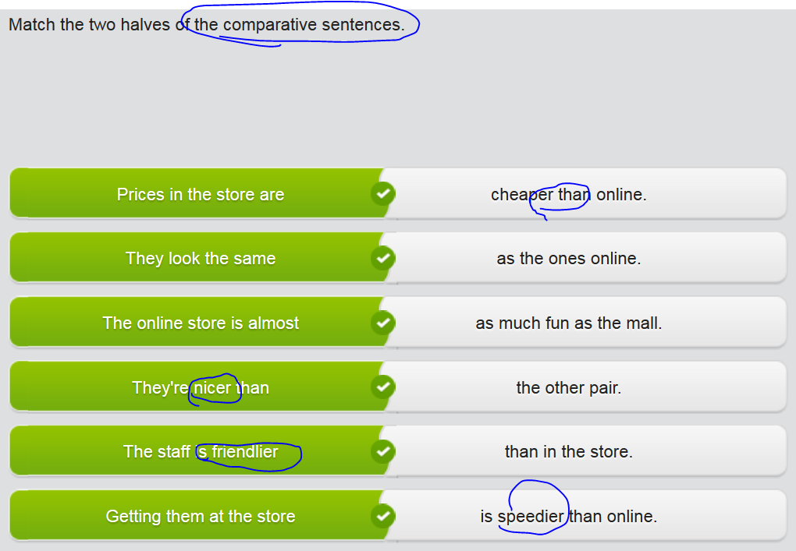

## 4th row) Analysing a problem

* The navigation looks nice but isn’t logical. This is a major **web usability** issue. We need to consider how customers will use the site. All of the things that they want should be available from the home page. Right now, there are too many clicks to get to the pages with the products. Let’s consider adding a navigation bar at the top that will allow users to go directly to different product categories.
* The design is really creative, but the most important things on the home page are difficult to find. I think the main issue is that you have to scroll to find the login area and the ‘Start Shopping’ button, though these are the first things our customers need when they come to our site.
* The site colors need to be rethought, as the black text on the gray background is difficult to read. It would be better to **incorporate** the brand colors **into** the design. A simple white background with blue and yellow navigation buttons to match the logo might work well.
* The styles are also a bit **problematic** ['prɑblə'mætɪk], as some of the pages have the product **thumbnails** to the right of the product descriptions and some have them to the left. They need to be consistent.
* The **shopping cart** doesn’t work properly if you add more than one item to it. The most common error is that some of the items simply disappear from the cart. This is definitely a problem tech will have to **sort out**/work out.
* **In general/overall,** our major issues have to do with functionality: internet users **are accustomed to** websites working a certain way. It’s nice to be original, but users don’t want to have to **figure out** how the site works. They’re visiting the site to see the products and then hopefully purchase. So let’s make that as easy as possible for them!

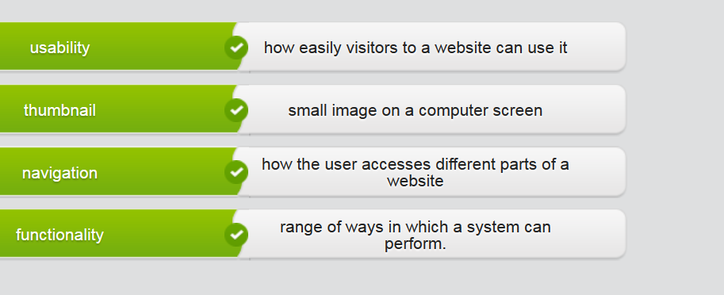

## STOP 5th row) Writing

Write a paragraph describing an e-commerce site (Amazon) you have used or heard about. Comment on the site's **functionality** and **product range**. How does it **compare to similar sites** (by using Venn diagram to compare A and B) ?

## Sample

[Comment on the site's **functionality** and **product range**.] I use Muzing.com for all my music needs. The unlimited streaming subscription is 9.99 bucks a month, and you can also purchase music from muzing.com for yourself or as gifts for others. **The sheer volume 总量of** music they have is **mind-blowing (extremely impressive or surprising)** – there are more than 20 million **tracks**, so it’s easy to find the music you love, and discover cool new tunes, too. Another highlight is that they allow you to keep 3000 **tracks** in storage on your device so that you can listen to music offline.

[How does it **compare to similar sites**] Muzing is far better than other music sites, both in terms of functionality and usability. I’ve tried several others, including Symphony.site, which I quickly quit because the music playlists were impossible to use. Another site, MIL streamed at a quality that was as high as Muzing, but **the streaming流畅** was constantly interrupted. Imagine listening to Bille Hliday singing “The way you look tonight’, and the song stops after she sings “There is nothing for me”. My recommendation. Go with Muzing.

## My writing

[ describing an e-commerce site (Amazon) you have used or heard about. ]

[ Comment on the site's **functionality** (e.gs web usability; wish list; and broad **product range**. ]

Amazon is my most favorite e-commerce website for my book needs. Its mature and diverse functionalities and super broad product range impress me a lot. Amazon’s user experience is awesome with its very user-friendly website interaction. For example, it can recommend a list of products that are closely related to the product you bought, especially with ratings and other buyers’ comments for your recommendation.

Furthermore, you cannot imagine how broad the product range that Amazon provides is, which provides customers tons of selections. Even though I don’t know the exact number of items of the inventory, it’s said that you can find anything you need here, even for **obscure 鲜为人知的**ones. **//obscure: not known or just known by very few people**

[ How does it **compare to similar sites** (by using Venn diagram to compare A and B) ? ]

Compare with other book websites, such as DingDing in China, I prefer to Amazon as my first choice because of Amazon’s amazing wish list **whereby/by which**, you can add any products that you search and want to buy from other websites into your Amazon wish list. What is more, all items in the wish list are compared with the counterparts from other online retailers.

In a nutshell, I'm a hot fan for Amazon for its nice website usability and flexible selection capability

# ** CNN related news or podcasts about making e-commerce, e.g.

## Amazon is rolling into Singapore, marking its first **foray 涉足/初次尝试 into** Southeast Asia.

<http://money.cnn.com/2017/07/26/technology/business/amazon-singapore-launch/index.html>

* [ **make a foray into** a new or unfamiliar type of activity], you start to become involved in it. **涉足，初次尝试(某个新的/不熟的领域/行业)**

Amazon, the e-commerce giant launched its two-hour delivery service Prime Now in Singapore on Thursday, offering tens of thousands of products -- everything from digital cameras **to diapers 尿布**to instant noodles -- for speedy delivery. It’s the first time for Amazon to **make a foray into** Asia.

Singapore's "**population density** works really well for us," said Asia Pacific director of Amazon. Singapore packs/populates more than 5.6 million people into an area about half the size Los Angeles. "For the first time, we can launch [Prime Now] and have it open to the entire country at the same time," Low said.

The service is free for orders that cost at least 40 **Singaporean [,siŋɡə'pɔ:riən] dollars ($29).** For an extra 10 **Singaporean dollars** ($7.37), shoppers can get their goods in an hour. Amazon (has been **teasing** the launch **on social media** for the last few days, **enlisting** **influential** Singaporean Instagram users to [post photos](https://www.instagram.com/p/BW15yBqgprd/?tagged=dontsaybojio) of the [seemingly random contents](https://www.instagram.com/p/BXAEBBVjiov/?tagged=dontsaybojio) of a Prime Now package.

The Seattle company will be going up against local rivals like Lazada, which is **bankrolled** by deep pocketed Chinese e-commerce giant Alibaba. Lazada currently offers same-day service for several thousand products. But Amazon "**has deep pockets and takes no prisoners**," said Mike, partner with **consulting firm咨询公司** Bain & Company. The online retailer **is "probably keen to go** up against Alibaba in a contained environment and try out its strategies and offerings."

Amazon is using its massive new **warehouse** in Singapore for Prime Now deliveries. Amazon also has brand recognition on its side. The company is leading in innovation with products and services like Echo and Prime. Southeast Asia's e-commerce industry pulled in $15 billion last year, and the number of digital consumers has **increased/skyrocketed/hiked/soared高涨** by 50% this year, according to a recent report from Bain, one of the most famous **consulting firm**.

"Singapore is a good first step," said Booker, adding that the small state's e-commerce market "is still in its **infancy婴儿期, 初期**." Low said Prime will be available in Singapore soon, but wouldn't **elaborate on** timing or price **对…作详细说明.**

**Reviewed by Anna J.:**

I love **Amazon’s** website. Besides the nice GUI view of **inventory** (a list of all products that are available to sale), **my favorite things about it are the book reviews and recommendations**. I’m sure that publishers and authors write nice reviews, **preface**序, and recommendations for their books, but I think most of the people writing about the books are average readers.

In the reviews, they say whether they liked or dislike about the book with reasonable comments and even solid evidences sometimes, **then rated it.** The Amazon website calculates the average rating for each book, so you can easily see even before reading the book reviews how many people have recommended a book. The book recommendations are lists of books that people create. For instance, a reader might start a list of books about history that they recommend. These reviews and recommendations really help to bring books that interest me to my attention.

Additionally, the delivery speed is so quick that it can reach you within 24 hrs.

**Reviewed by Ethan R.:**

I like **Amazon** because of its huge choice, with the amazing **inventory (a list of products that are available for sale)** for you to browse. You can find just about any book there, and that’s good for me since I like to read **science fiction** books that are really difficult to find in book stores. I also often buy books for my friends and family who like to read **unusual books**. For instance, my sister is always looking for really old English books that aren’t being printed anymore. If I can’t find new copies of these books for her on Amazon, I can at least find a used copy through one of the used book sellers working with Amazon.

Additionally, the delivery speed is so quick that it can reach you within 24 hrs.

## Amazon enters Southeast Asia, launching Prime Now service in Singapore

<http://money.cnn.com/2017/07/26/technology/business/amazon-singapore-launch/index.html>

The e-commerce giant launched its two-hour delivery service Prime Now in Singapore on Thursday, offering tens of thousands of products -- everything from champagne to diapers to instant noodles -- for speedy delivery.

Singapore's "density works really well for us," said Henry Low, Asia Pacific director of Amazon Prime Now. Singapore packs more than 5.6 million people into an area about half the size Los Angeles.

"For the first time, we can launch [Prime Now] and have it open to the entire country at the same time," Low said.

The service is free for orders that cost at least40 Singaporean dollars($29). For an extra 10 Singaporean dollars ($7.37), shoppers can get their goods in an hour.

[Related: Amazon will make thousands of job offers next week](http://money.cnn.com/2017/07/26/technology/business/amazon-jobs-fair/index.html?iid=EL)

Amazon ([AMZN](http://money.cnn.com/quote/quote.html?symb=AMZN&source=story_quote_link), [Tech30](http://money.cnn.com/technology/tech30/index.html?iid=EL)) has been teasing the launch on social media for the last few days, enlisting influential Singaporean Instagram users to [post photos](https://www.instagram.com/p/BW15yBqgprd/?tagged=dontsaybojio) of the [seemingly random contents](https://www.instagram.com/p/BXAEBBVjiov/?tagged=dontsaybojio) of a Prime Now package.

The Seattle company will be going up against local rivals like Lazada, which is bankrolled by deep pocketed Chinese e-commerce giant Alibaba ([BABA](http://money.cnn.com/quote/quote.html?symb=BABA&source=story_quote_link), [Tech30](http://money.cnn.com/technology/tech30/index.html?iid=EL)). Lazada currently offers same-day service for several thousand products.

But Amazon "has deep pockets and takes no prisoners," said Mike Booker, partner with consulting firm Bain & Company. The online retaileris "probably keen to go up against Alibaba in a contained environment and try out its strategies and offerings," he added.

Amazon also has brand recognition on its side.

The company is leading in innovation with products and services like Echo and Prime, said Sandy Shen, an analyst with research firm Gartner. "No other e-commerce players have anything similar or even close," she said.

Southeast Asia's e-commerce industry pulled in $15 billion last year, and the number of digital consumers has increased 50% this year, according to a recent report from Bain.

[Related: Amazon's new strategy for India: Prime Day deals and food](http://money.cnn.com/2017/07/11/technology/amazon-prime-day-india-grocery-flipkart/index.html?iid=EL)

"Singapore is a good first step," said Booker, adding that the small state's e-commerce market "is still in its infancy."

Only 6.5% of retail in Singapore is online,compared to 25% in China and 16% in the U.S.

Amazon shoppers usually need to pony up for Prime membership to access Prime Now perks. In the U.S., Prime's annual $99 fee gets members two-day shipping on many products, as well as access to streaming video and music services.

Amazon's newly built 100,000 square foot warehouse in Singapore seems poised for Prime service, but the launch appears to be delayed.

Low said Prime will be available in Singapore soon, but wouldn't elaborate on timing or price.